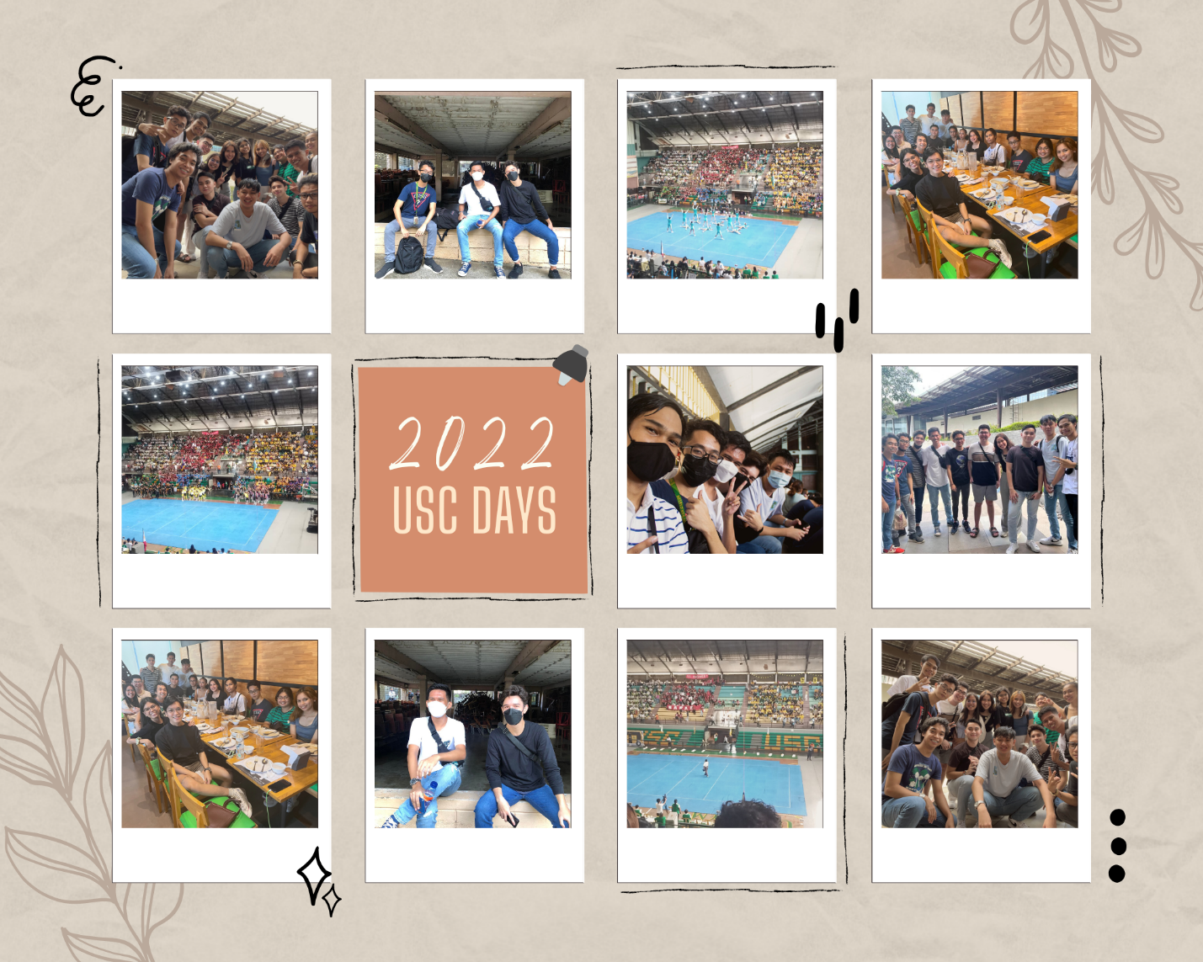

The highlight of my USC Days experience would be attending the Opening Ceremony with my friends from Computer Science at the University of San Carlos – Downtown Campus. It was very memorable for me because this is the first time, I spent face-to-face time with my friends in my entire college life so far. I had fun meeting them and watching the event with them and even having lunch together over at Ayala.

It was disappointing the SAS cheerdance team didn’t win anything but what was even more disappointing was the fact that there were no stunts allowed such as lifting during the performance. That for me was part of the essence of cheerdance (since I was a member during SHS). I had fun watching SBE cheerdance performance because of their choice of costume and their synchronous dance steps.

I also spectated some sports activities such as basketball and esports activities such as ML and LoL. Intramurals would be far more enjoyable if everyone was allowed to participate in all the events without restrictions but unfortunately, we still have to abide by pandemic rules because of possible covid infection.

Overall, it was a wonderful experience.